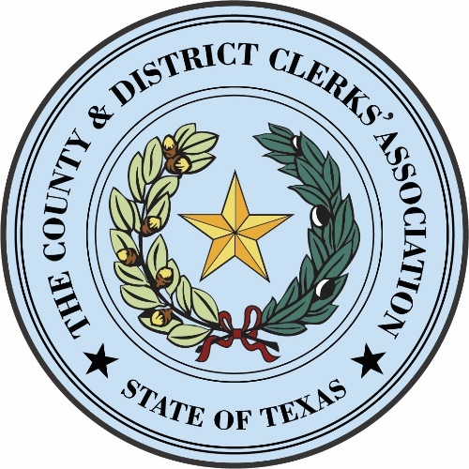

The County & District Clerks’ Association of Texas
Virtual Board of Directors Meeting
Meeting Date: February 15, 2024 @ 4:00 P.M.
MEETING MINUTES
(Documentation provided during this meeting is attached hereto)

Call to Order- Julie Smith, CDCAT President at 4:03 P.M.

Roll Call- Jennifer Wright, Secretary

Officers President – Julie Smith, Potter County Clerk
Vice President – John Warren, Dallas County Clerk
Treasurer – Sandra Roblez, Yoakum County District Clerk
Secretary – Jennifer Wright, Jeff Davis County & District Clerk
Immediate Past President – Patti Henry, Chambers County District Clerk
Parliamentarian - Karren Winter, Archer County Clerk

Board Members
Director-In-Charge Director

Region I C.J. Chasco, Swisher County Combo Clerk JoAnna Blanco, Castro County Combo Clerk
Region II Kelly Pinion, Lubbock County Clerk Vickey Wederski, Cottle County Combo Clerk
Region III Clarissa Webster, Ector County District Clerk Jennifer Martin, Ector County Clerk
Region IV Lucy Adame-Clark, Bexar County Clerk Velva Price, Travis County District Clerk
Region V Edith Harrison, Lampasas County District Clerk Juli Luke, Denton County Clerk
Region VI Ex Loretta Cammack, Nacogdoches Co. District Clerk Shawn Weemes, Red River County Clerk
Region VII Bobbye Christopher, Polk County District Clerk Ex Donece Gregory, Tyler County Clerk
Region VIII Sylvia Garza Perez, Cameron County Clerk R. David Guerrero, Jim Wells County District Clerk
*Everyone present has signed a waiver.

GUESTS
Becky Frost, Zachry Publications
Karen Gladney, legal counsel
Jay Williamson, Williamson Public Affairs
Jim Grace
Luz Hinojosa, TAC

Invocation - John Warren, Vice President
Pledges to the American and Texas Flags - Sandra Roblez, Treasurer

- Discussion, Consideration and Approval of the following items as needed:

- Discussion of retaining a lobbyist for CDCAT and recommending a contract amount.
Sylvia Garza Perez makes a motion that we go ahead accept the agreement and proposal
that you have reviewed and that we have received. Kelly Pinion seconded. All in favor.
Motion carries.

b. Authorizing the CDCAT bookkeeper to create two separate accounts at First Financial Bank to
deposit monies received from corporate entities, and one to deposit monies received from
public entities.
Patti Henry makes a motion that we authorize Zachry Publishing to create two separate accounts at First Financial Bank to deposit monies received from corporate entities, and one to deposit monies received from public entities. Lucy Adame-Clark, Bexar County, second. All in favor. Motion carries.

c. Discussion and recommendation of CDCAT officer with authority over accounts established at
First Financial Bank by the CDCAT bookkeeper.
Clarissa Webster, District Clerk Ector County, makes a motion that the authority over the accounts be the Treasurer and the President of our association alongside Becky Frost for the purposes of having authority over these accounts at First Financial Bank. R. David Guerrero seconds. All in favor. Motion carries.

d. To name the “signers” of the accounts established at First Financial Bank by the CDCAT
bookkeeper.
Velva Price hardly, hardly, hardly make that motion that the signers on the account be the President, the Vice President and the Treasurer only. Juli Luke seconds. All in favor. Motion carries.

e. To consider authorizing the CDCAT website designer, David Bray, to make additions to the
CDCAT tracker in order to add a group manager, add the ability to group and ungroup clerks
from the contact list, and add support for selecting groups during the email process. The hours
estimated by David Bray to complete the project are 15 to 18 hours.
Velva Price makes a motion that we approve website designer, David Bray, to make additions to the CDCAT tracker in order to add a group manager, add the ability to group and ungroup clerks from the contact list, and add support for selecting groups during the email process in consultation with the website group so that we do not have to say specifically what it is and that it not exceed $3,500.00. That we also add disclaimer language; this email messaging platform can only be used for the promotion and business of the Clerk Association. Lucy Adame-Clark second. All in favor

2.New/Future Business:

Karen Gladney is going to hang up her hat. She will still come to the Summer Conference as she
will retire from us the end of June and we welcome any recommendations anyone might have.

- Adjourn – 4:55 P.M.
Sandra Roblez makes a motion to adjourn. JoAnna Blanco seconds. All in favor.

Submitted on the 15th day of February 2024.
/s/ Jennifer Wright
Jennifer Wright
Jeff Davis County and District Clerk
Secretary, County and District Clerks’ Association of Texas

